**MongoDB - Complex Queries**

**Database Name : restaurants**

**Collection Name: addresses**

1. Write a MongoDB query to display all the documents in the collection restaurants.

db.addresses.find()

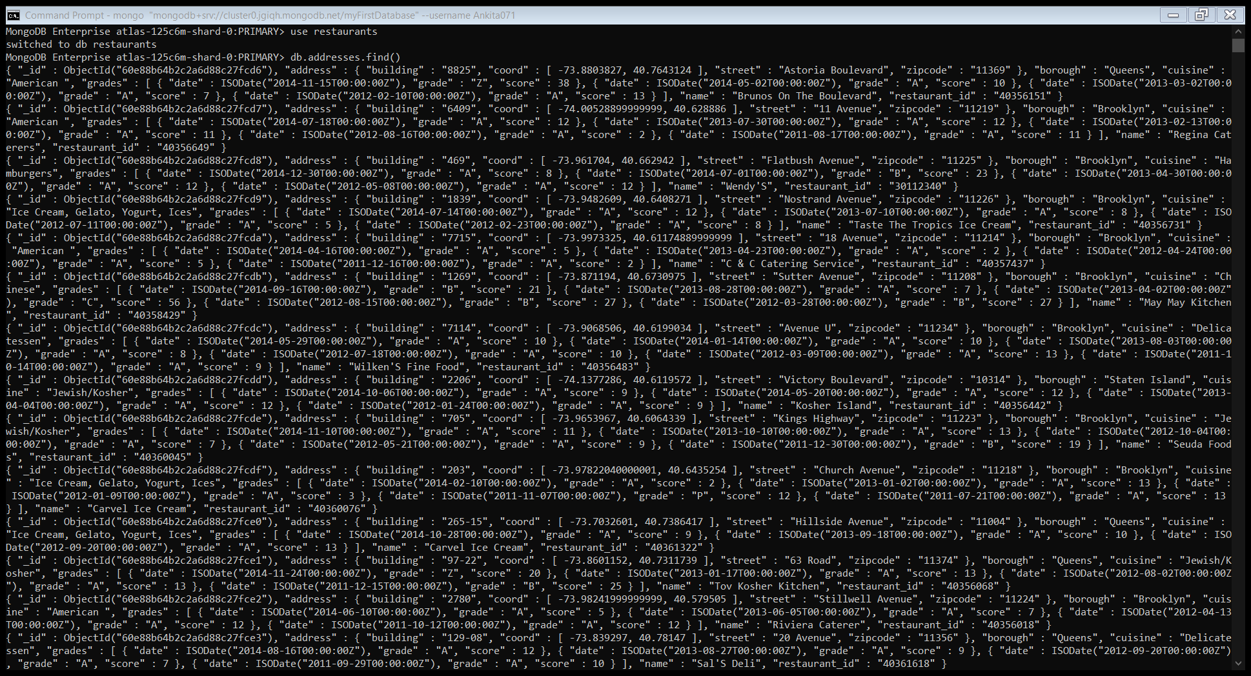

2. Write a MongoDB query to display the fields restaurant_id, name, borough and cuisine for all the documents in the collection restaurant.

db.addresses.find({}, {_id:1, name:1, cuisine: 1, borough: 1, restaurant_id: 1})

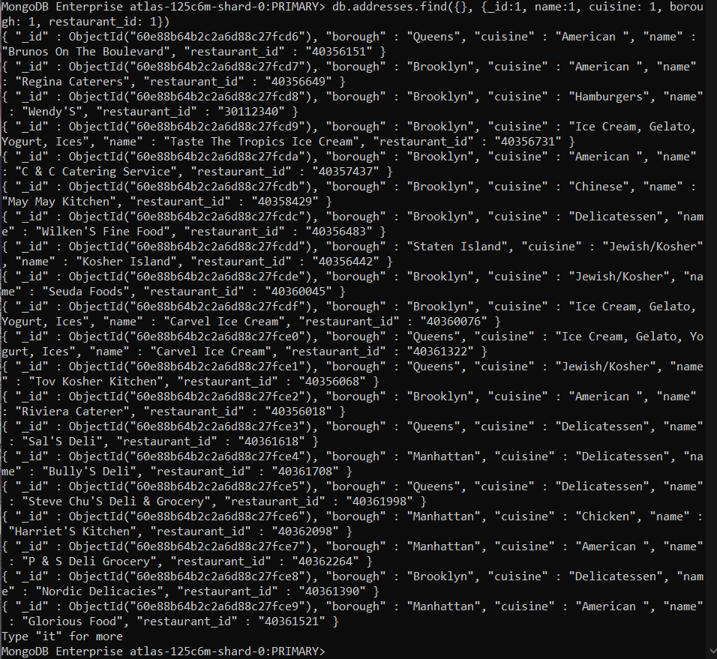

3. Write a MongoDB query to display the fields restaurant_id, name, borough and cuisine, but exclude the field_id for all the documents in the collection restaurant.

db.addresses.find({}, {_id:0, name:1, cuisine: 1, borough: 1, restaurant_id: 1})

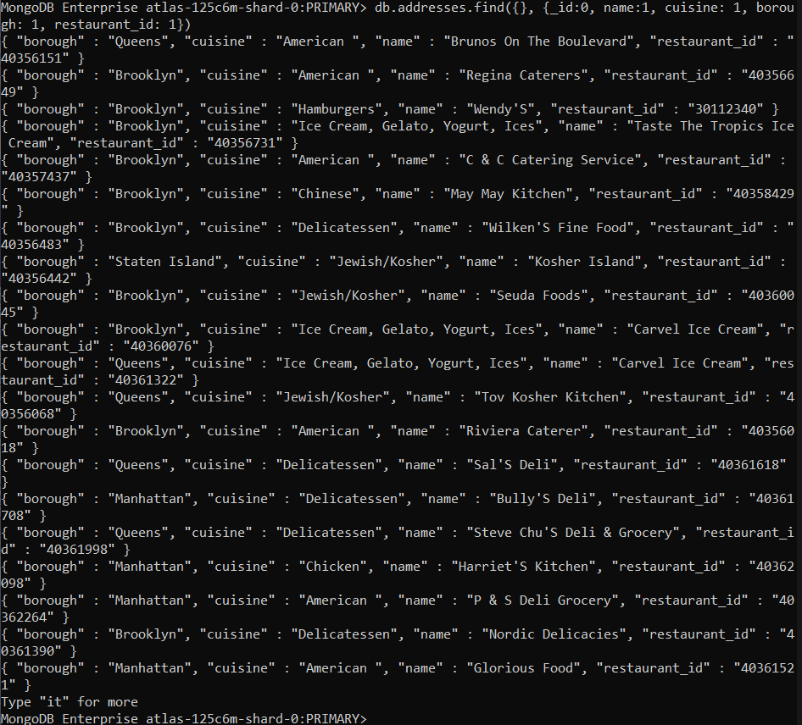

4. Write a MongoDB query to display the fields restaurant_id, name, borough and zip code, but exclude the field_id for all the documents in the collection restaurant.

db.addresses.find({}, {_id:0, name:1, cuisine: 1, borough: 1, restaurant_id: 1, "address.zip code":1})

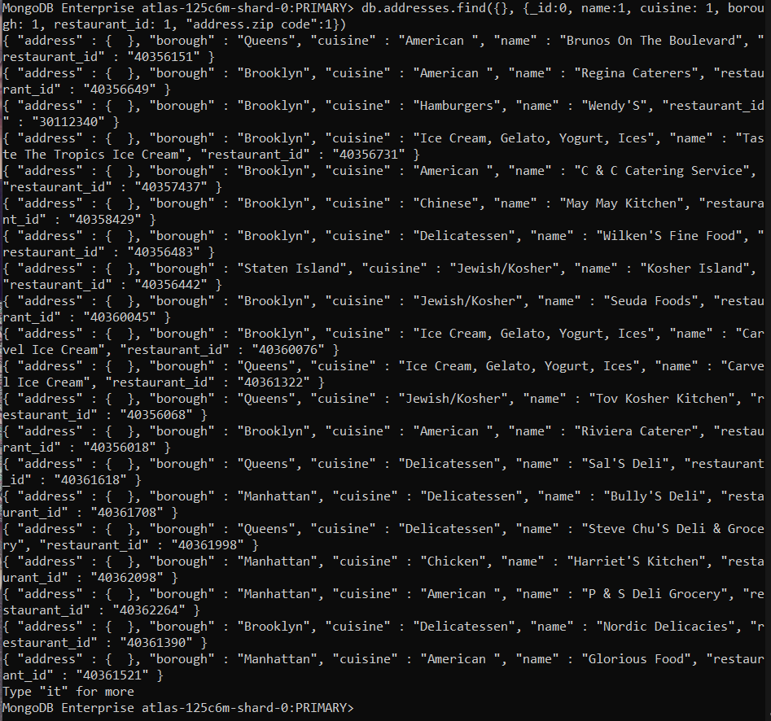

5. Write a MongoDB query to display the first 5 restaurant which is in the borough Bronx.

db.addresses.find({"borough":"Bronx"}).limit(5)

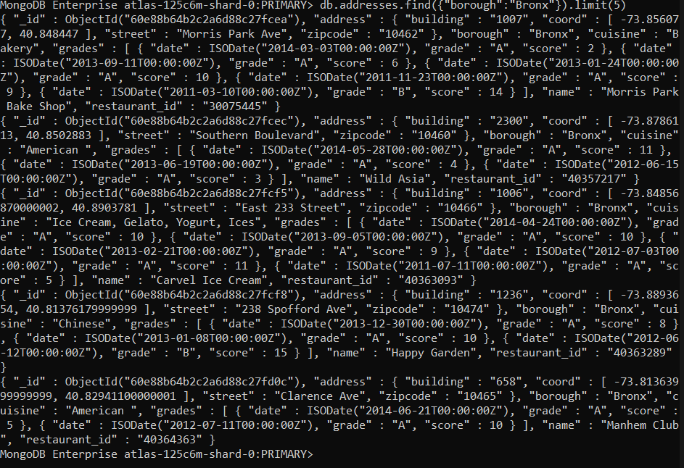

6. Write a MongoDB query to display all the restaurant which is in the borough Bronx.

db.addresses.find({"borough":"Bronx"})

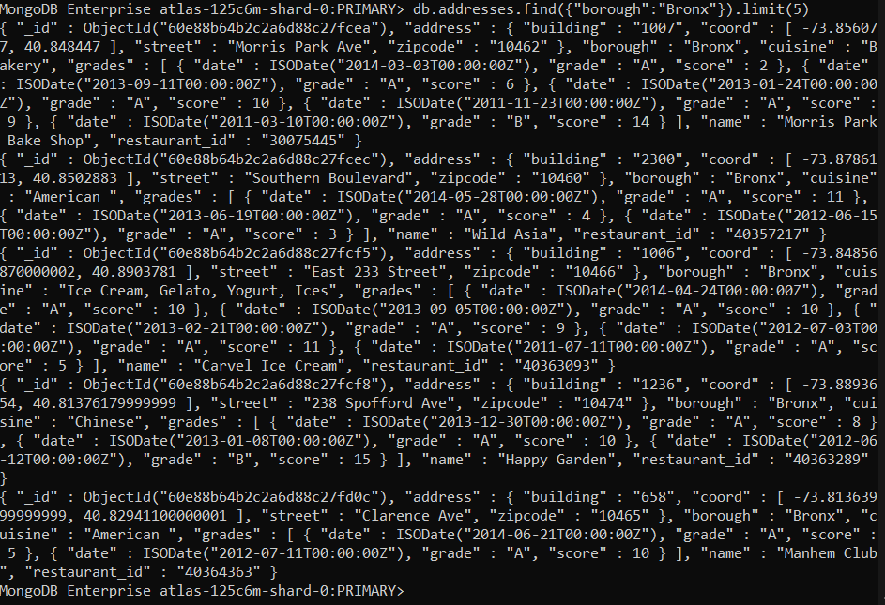

7. Write a MongoDB query to display the next 5 restaurants after skipping first 5 which are in the borough Bronx.

db.addresses.find({"borough":"Bronx"}).skip(5).limit(5)

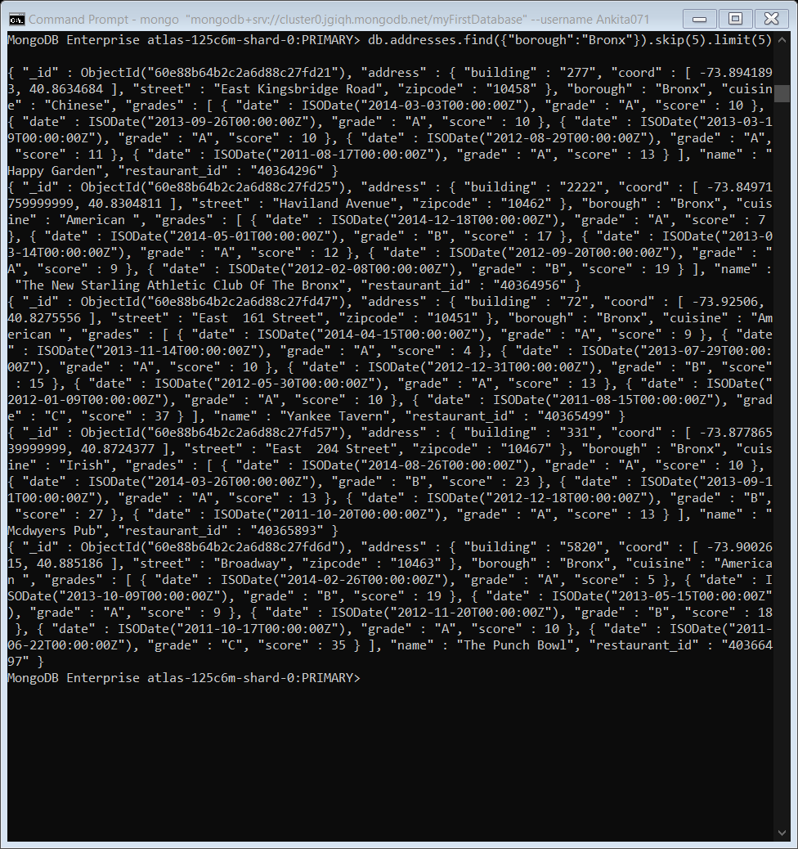

8. Write a MongoDB query to find the restaurants who achieved a score more than 90.

db.addresses.find({"grades.score" : {"$gt" : 90}})

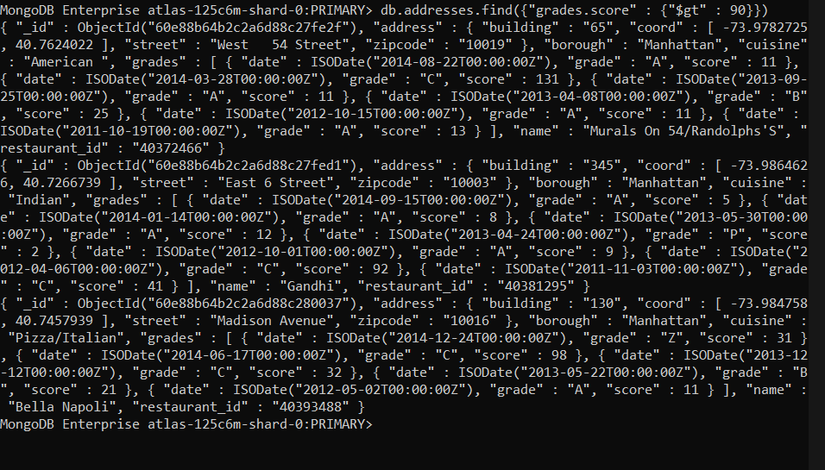

9. Write a MongoDB query to find the restaurants that achieved a score, more than 80 but less than 100.

db.addresses.find({$and:[{"grades.score" : {"$gt" : 80}},{"grades.score" : {"$lt" : 100}}]})

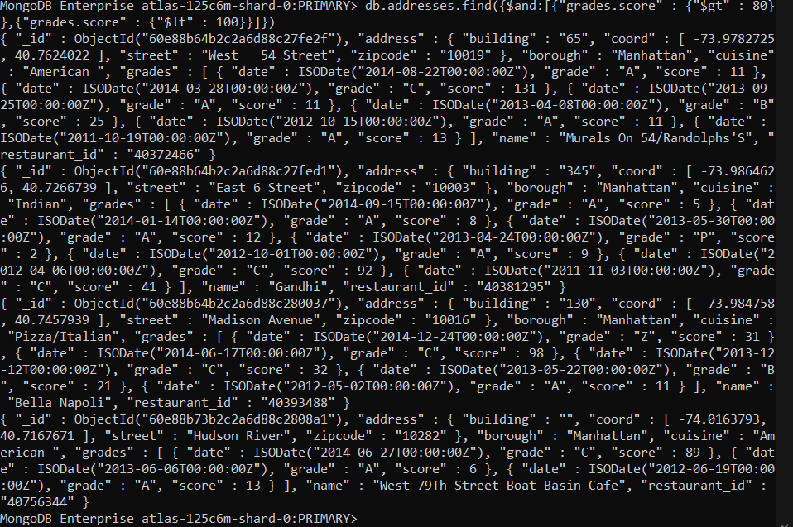

10. Write a MongoDB query to find the restaurants which locate in latitude value less than -95.754168

db.addresses.find({"address.coord.0" : {$lt : -95.754168}})

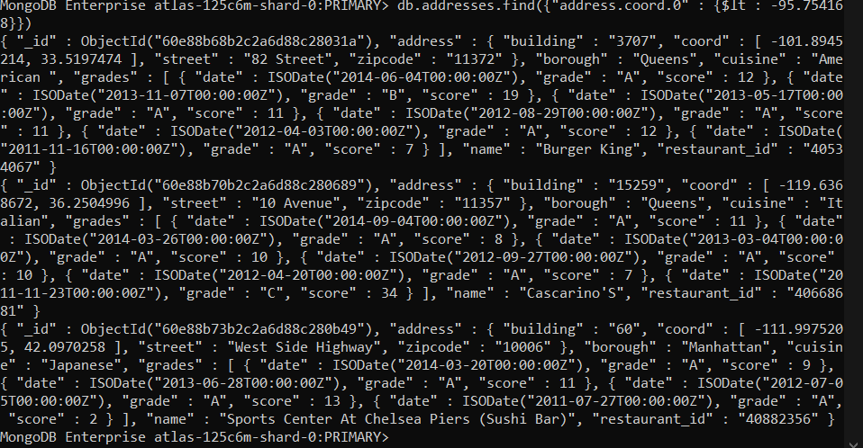

11. Write a MongoDB query to find the restaurants that do not prepare any cuisine of American and their grade score more than 70 and latitude less than -65.754168.

db.addresses.find({$and : [{"cuisine" : {$ne : "American "}}, {"address.coord.0" : {$lt : -65.754168}}, {"grades.score" : {$gt : 70}}]})

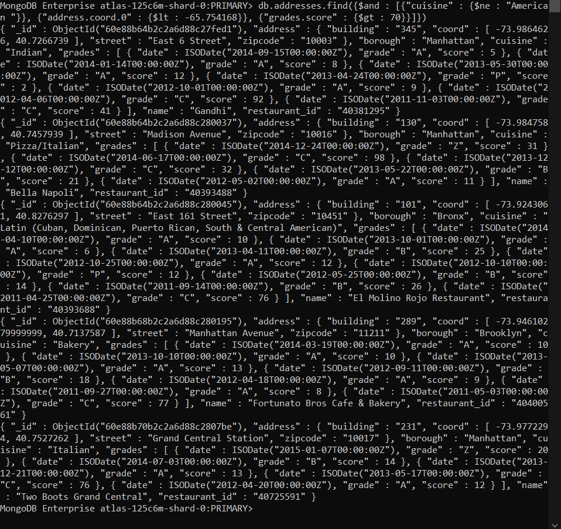

12. Write a MongoDB query to find the restaurants which do not prepare any cuisine of American and achieved a score more than 70 and located in the longitude less than -65.754168.

db.addresses.find({$and : [{"cuisine" : {$ne : "American "}}, {"address.coord" : {$lt : -65.754168}}, {"grades.score" : {$gt : 70}}]})

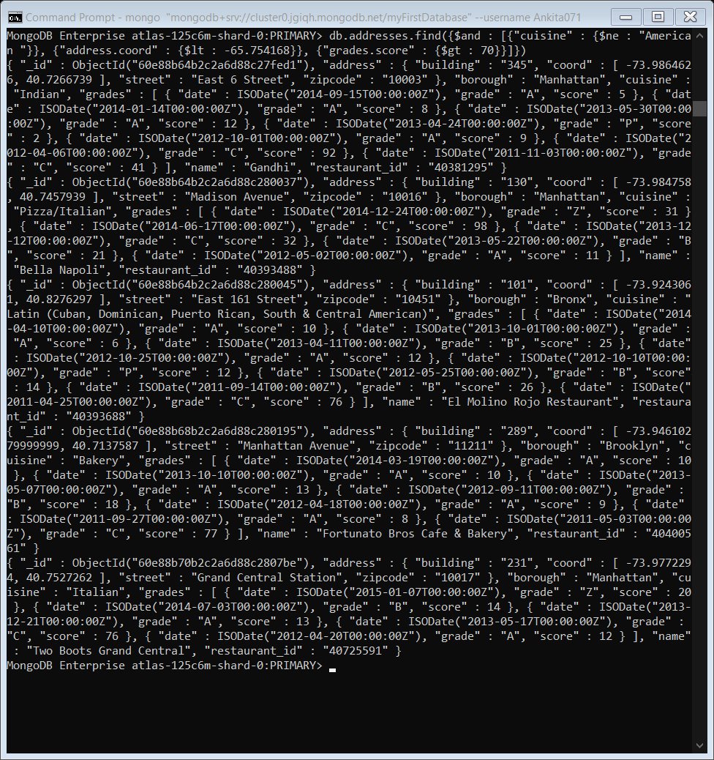

13. Write a MongoDB query to find the restaurants which do not prepare any cuisine of 'American and achieved a grade point 'A' not belongs to the borough Brooklyn. The document must be displayed according to the cuisine in descending order.

db.addresses.find({$and : [{"cuisine" : {$ne : "American "}}, {"grades.grade" : "A"}, {"borough" : {$ne : "Brooklyn "}}]}).sort({cuisine : -1})

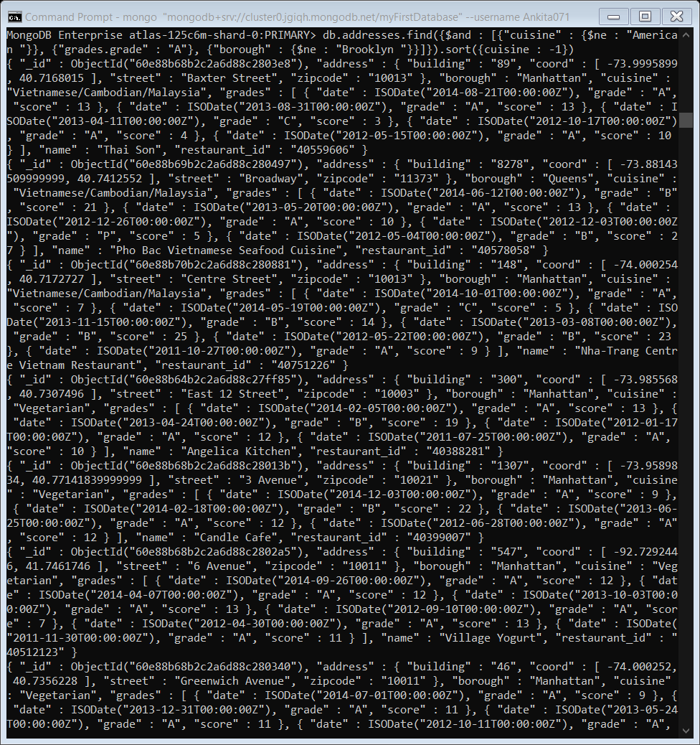

14. Write a MongoDB query to find the restaurant Id, name, borough and cuisine for those restaurants which contain 'Wil' as first three letters for its name.

db.addresses.find({"name" : { $regex: /^Wil.*/}}, {_id:0, restaurant_id:1, name:1, borough:1, cuisine:1})

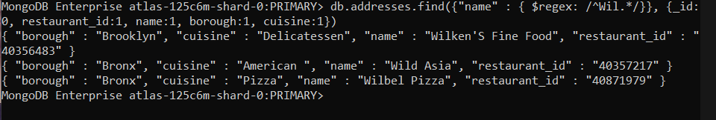

15. Write a MongoDB query to find the restaurant Id, name, borough and cuisine for those restaurants which contain 'ces' as last three letters for its name.

db.addresses.find({"name" : { $regex: /.*ces$/}}, {_id:0, restaurant_id:1, name:1, borough:1, cuisine:1})

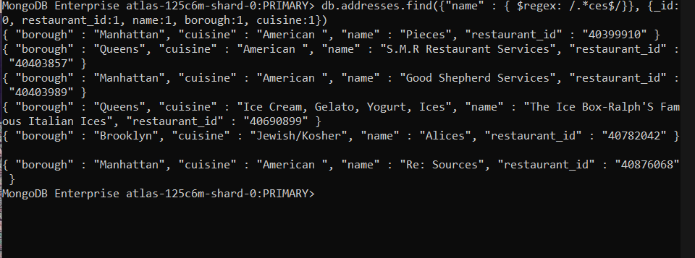

16. Write a MongoDB query to find the restaurant Id, name, borough and cuisine for those restaurants which contain 'Reg' as three letters somewhere in its name.

db.addresses.find({"name" : { $regex: /Reg/}}, {_id:0, restaurant_id:1, name:1, borough:1, cuisine:1})

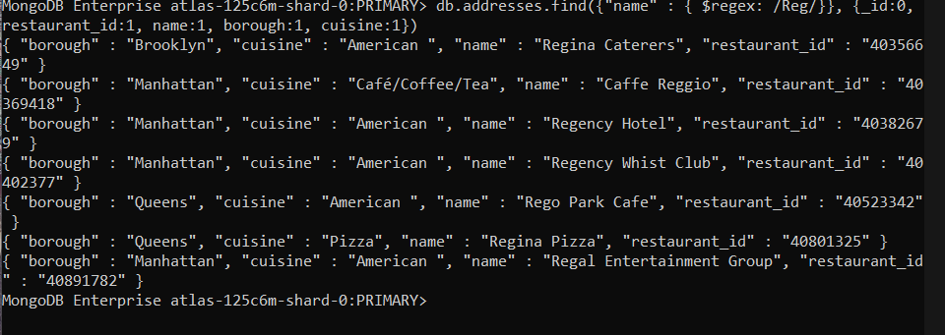

17. Write a MongoDB query to find the restaurants which belong to the borough Bronx and prepared either American or Chinese dish.

db.addresses.find({borough: "Bronx", cuisine: {$in: ["American ","Chinese"]}}, {_id:0, restaurant_id:1, name:1, borough:1, cuisine:1})

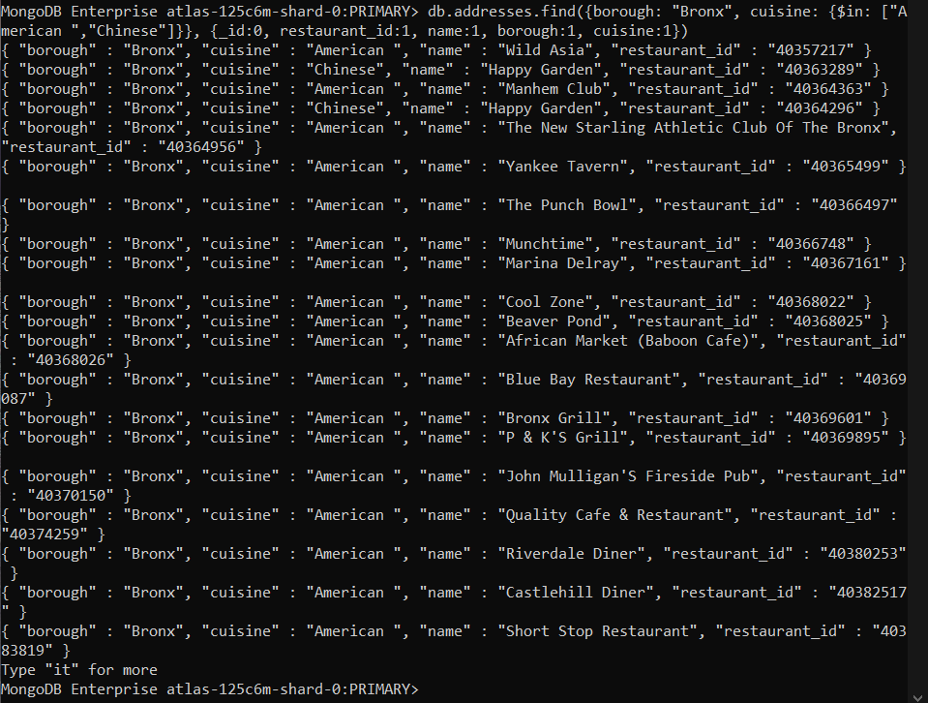

18. Write a MongoDB query to find the restaurant Id, name, borough and cuisine for those restaurants which belong to the borough Staten Island or Queens or Bronx or Brooklyn.

db.addresses.find({$or: [{"borough": "Staten Island"}, {"borough": "Bronx or Brooklyn"}, {"borough": "Queens"}]}, {_id:0, restaurant_id:1, name:1, borough:1, cuisine:1})

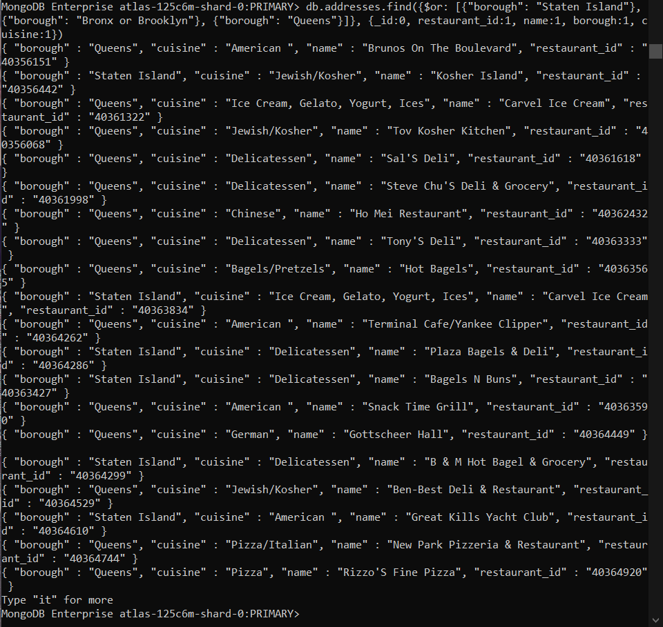

19. Write a MongoDB query to find the restaurant Id, name, borough and cuisine for those restaurants which are not belonging to the borough Staten Island or Queens or Bronx or Brooklyn.

db.addresses.find( {borough: {$nin: ["Staten Island","Queens","Bronx","Brooklyn"]}} , {_id:0, restaurant_id:1, name:1, borough:1, cuisine:1})

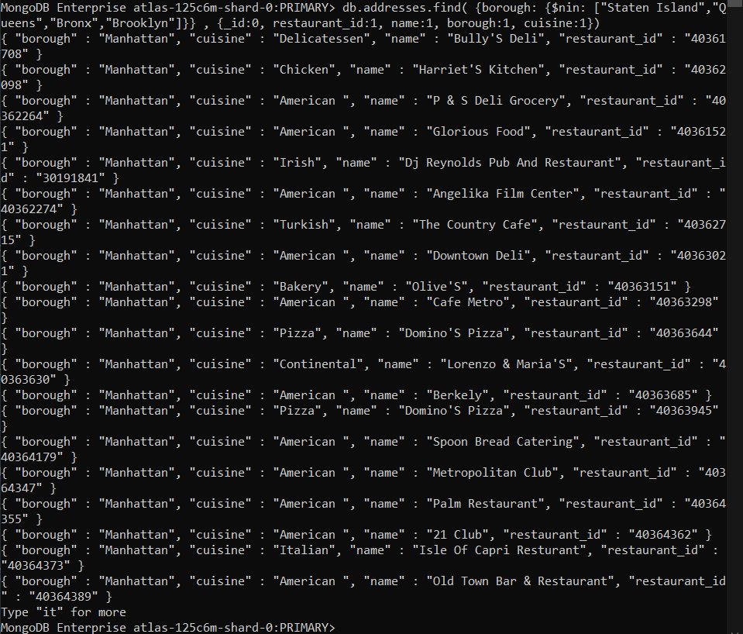

20. Write a MongoDB query to find the restaurant Id, name, borough and cuisine for those restaurants which achieved a score which is not more than 10.

db.addresses.find({"grades.score": {$lt: 10}}, {_id:0, restaurant_id:1, name:1, borough:1, cuisine:1})

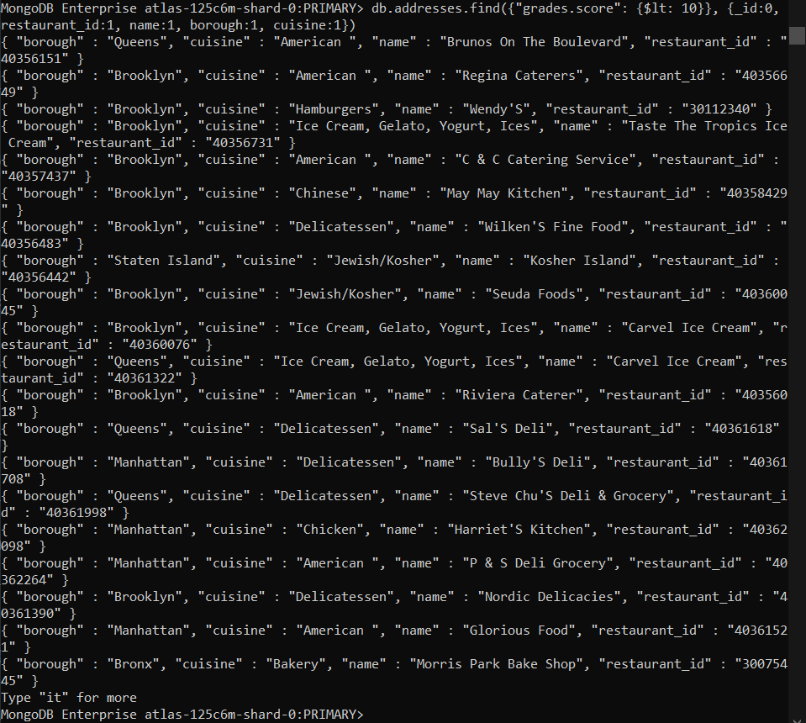

21. Write a MongoDB query to find the restaurant Id, name, borough and cuisine for those restaurants which prepared dish except 'American' and 'Chinees' or restaurant's name begins with letter 'Wil'.

db.addresses.find({$nor: [{cuisine: {$in: ["American ","Chinese"]}},{name: /^Wil.*/}]},{_id:0, restaurant_id:1, name:1, borough:1, cuisine:1})

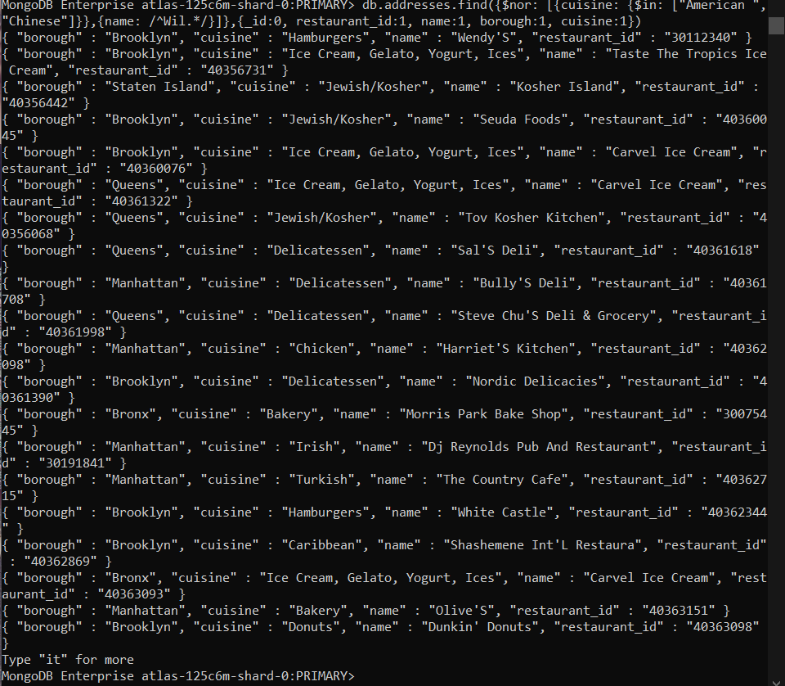

22. Write a MongoDB query to find the restaurant Id, name, and grades for those restaurants which achieved a grade of "A" and scored 11 on an ISODate "2014-08-11T00:00:00Z" among many of survey dates..

db.addresses.find({"grades" : {$elemMatch: {"date": ISODate("2014-08-11T00:00:00Z"), "grade":"A", "score":11}}}, {_id:0, restaurant_id:1, name:1, grades:1})

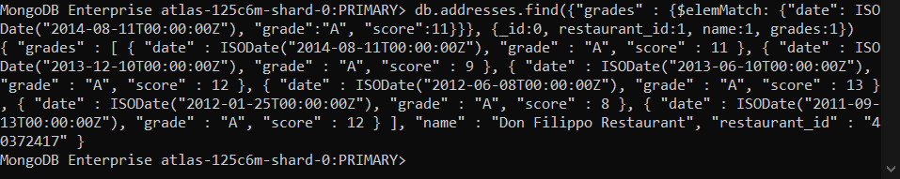

23. Write a MongoDB query to find the restaurant Id, name and grades for those restaurants where the 2nd element of grades array contains a grade of "A" and score 9 on an ISODate "2014-08-11T00:00:00Z"

db.addresses.find({$and: [{"grades.1.grade":"A"}, {"grades.1.score": 9}, {"grades.1.date": ISODate("2014-08-11T00:00:00Z")}]},{_id:0, restaurant_id:1, name:1, grades:1})

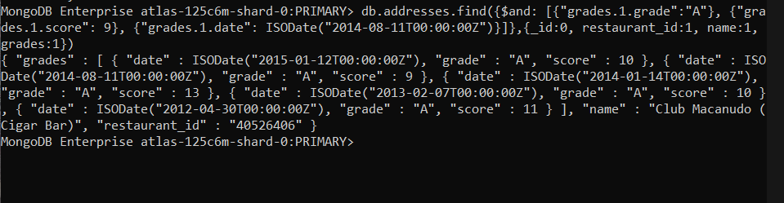

24. Write a MongoDB query to find the restaurant Id, name, address and geographical location for those restaurants where 2nd element of coord array contains a value which is more than 42 and upto 52..

db.addresses.find({$and : [{"address.coord.1": {$gt : 42}},{"address.coord.1": {$lte : 52}}]}, {_id:0, restaurant_id:1, name:1, address:1})

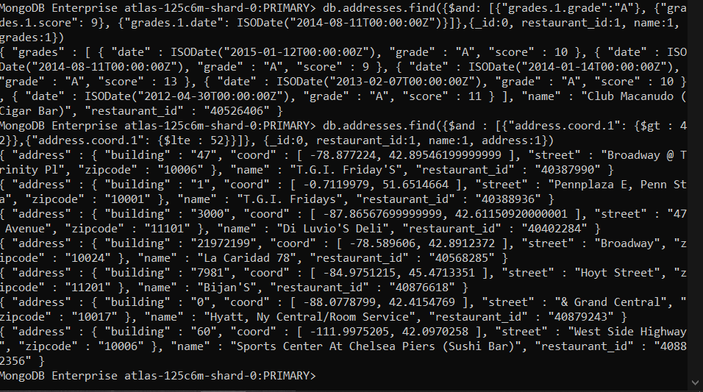

25. Write a MongoDB query to arrange the name of the restaurants in ascending order along with all the columns.

db.addresses.find({}).sort( {name: 1})

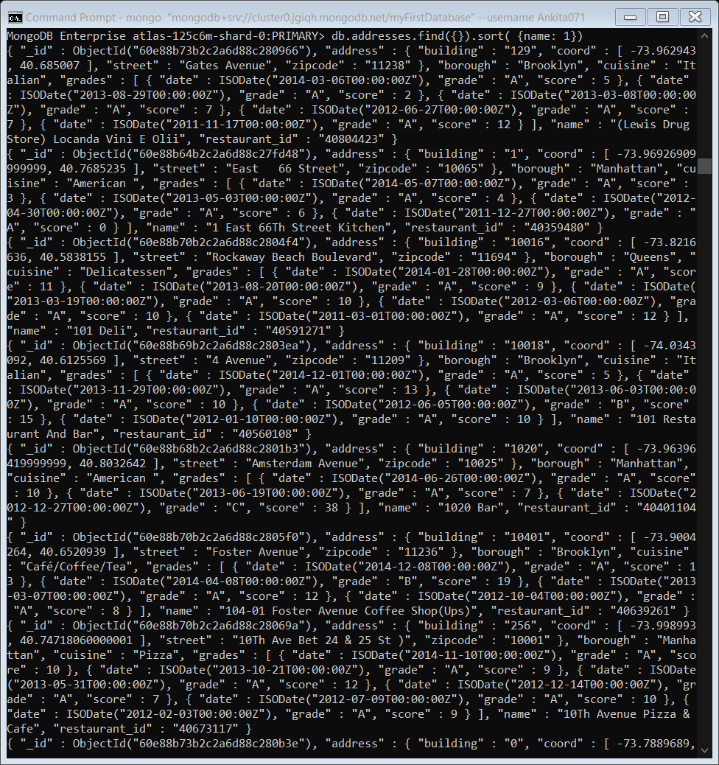

26. Write a MongoDB query to arrange the name of the restaurants in descending along with all the columns.

db.addresses.find({}).sort( {name: -1})

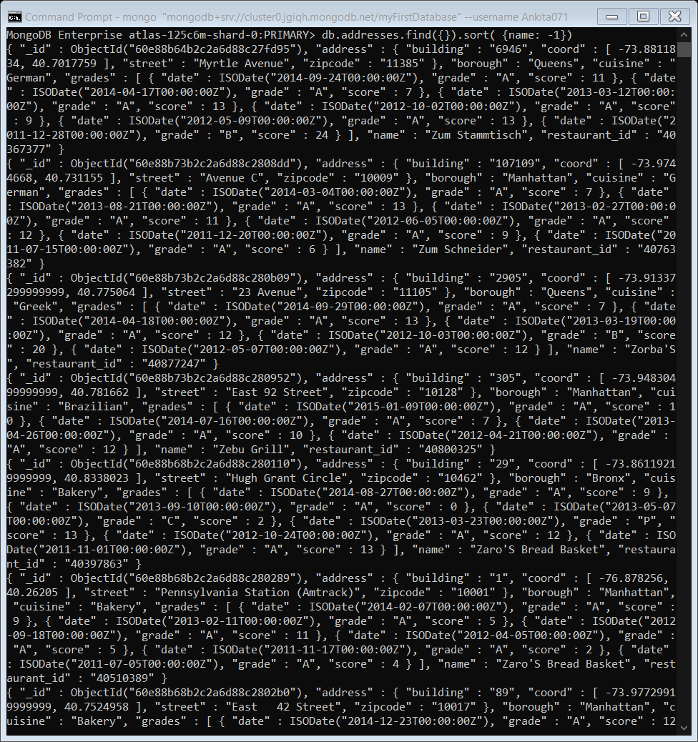

27. Write a MongoDB query to arranged the name of the cuisine in ascending order and for that same cuisine borough should be in descending order.

db.addresses.find({}, {_id:0, cuisine:1, borough:1}).sort({cuisine: 1, borough: -1})

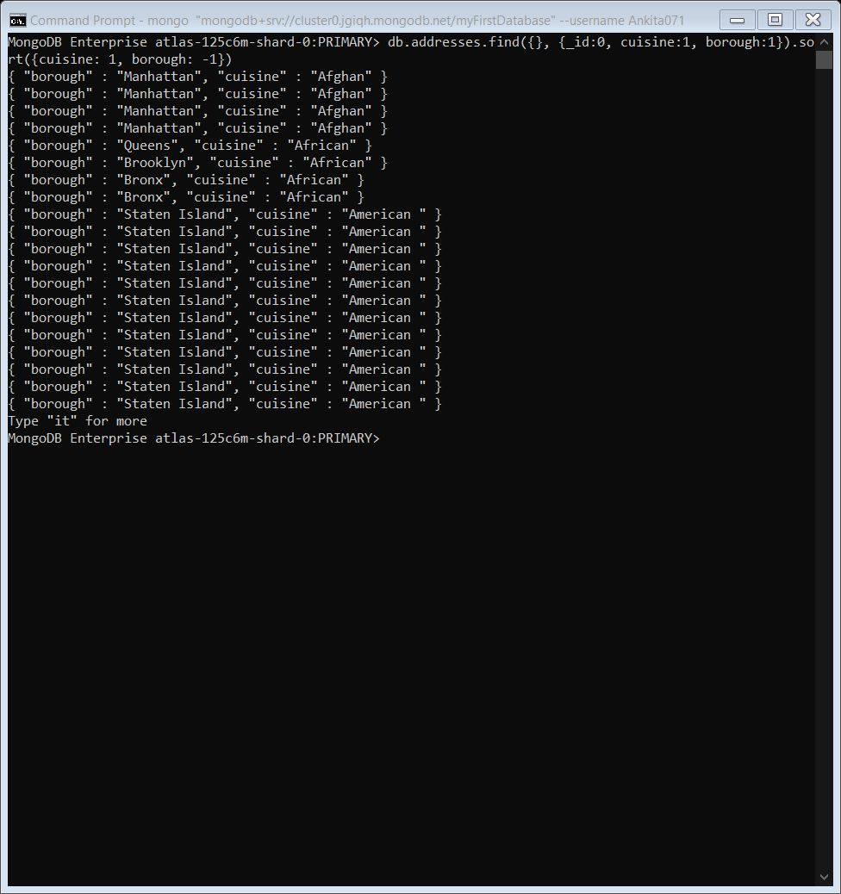

28. Write a MongoDB query to know whether all the addresses contains the street or not.

db.addresses.find({"address.street": {$regex: /Street/}})

db.addresses.find({"address.street": {$ne: {$regex: /Street/}}})

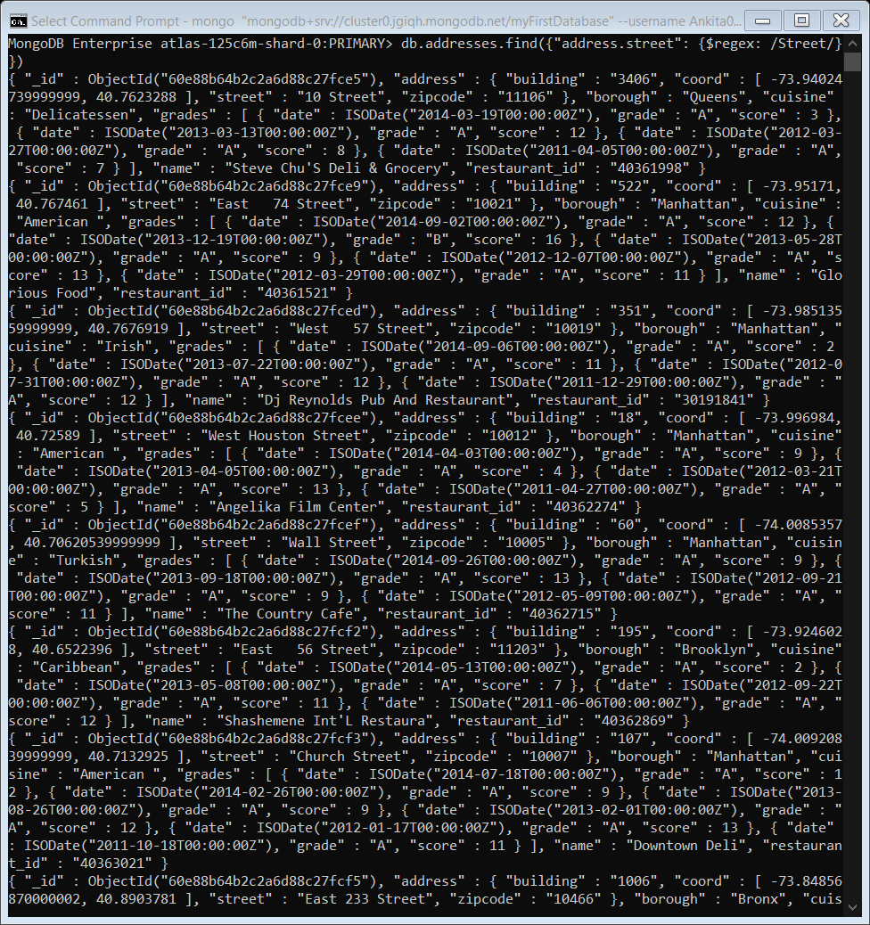

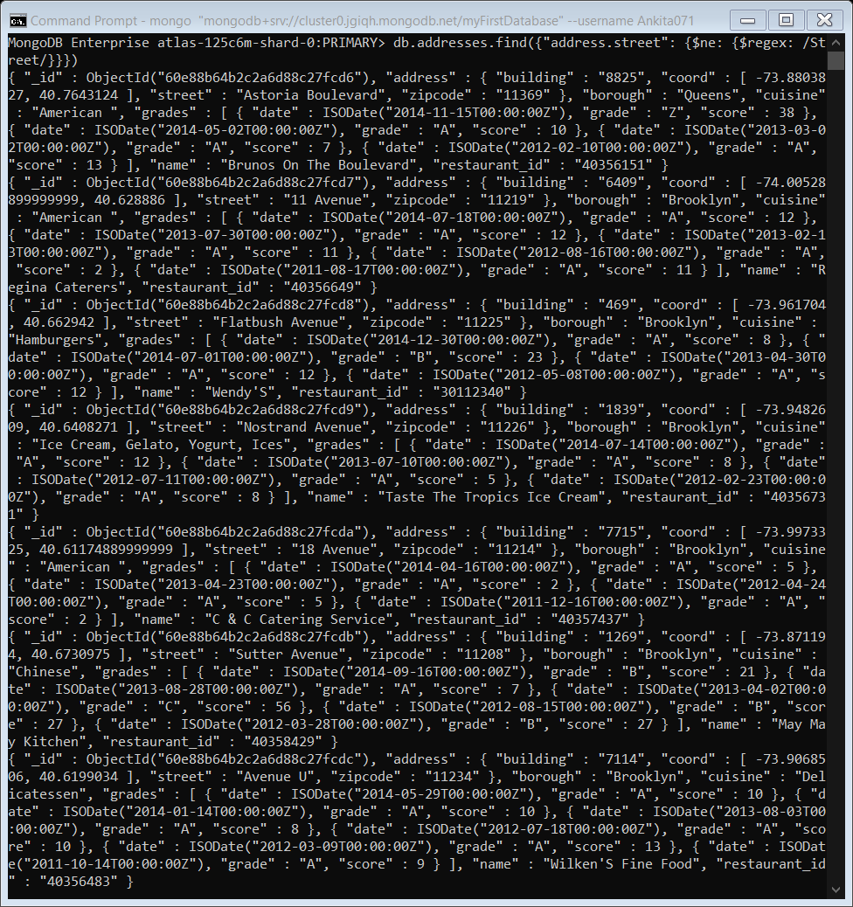

29. Write a MongoDB query which will select all documents in the restaurants collection where the coord field value is Double.

db.addresses.find({"address.coord": {$type: "double"}}, {_id:0, address:1})

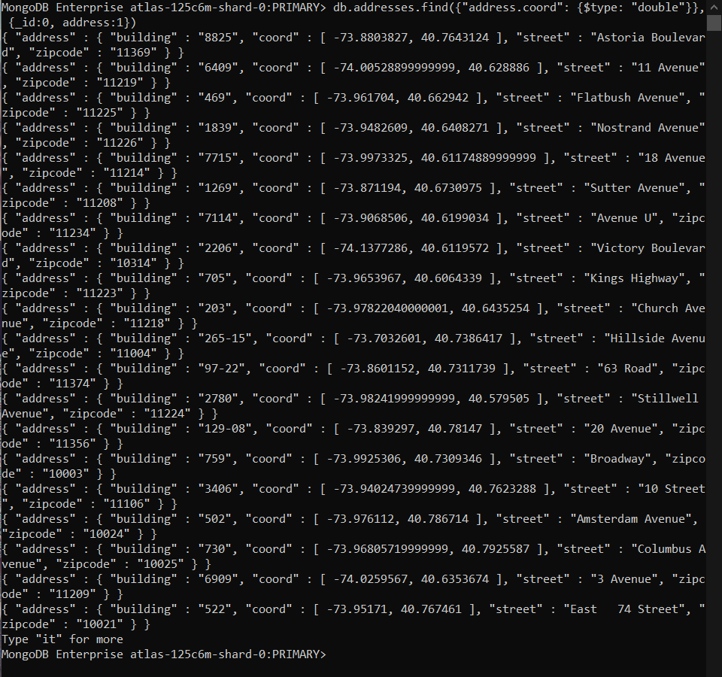

30. Write a MongoDB query which will select the restaurant id name and grades for those restaurants which returns û as a remainder after dividing the score by 7.

db.addresses.find({"grades": {$elemMatch: {"score": {$mod: [7,0]}}}},{_id:0, restaurant_id:1, name:1, grades:1})

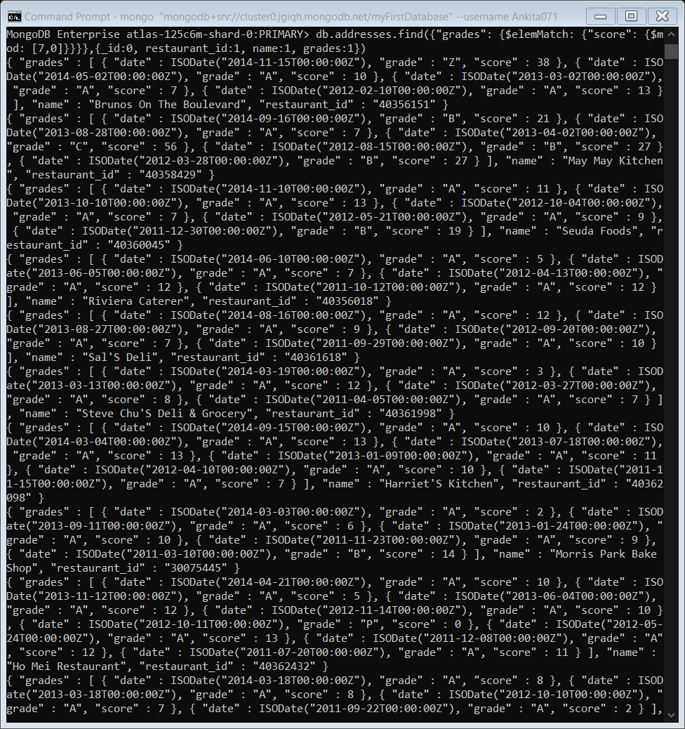

31. Write a MongoDB query to find the restaurant name, borough, longitude and attitude and cuisine for those restaurants which contains 'mon' as three letters somewhere in its name.

db.addresses.find({name: {$regex: /mon/}},{_id:0, name:1, borough:1, "address.coord":1, cuisine:1})

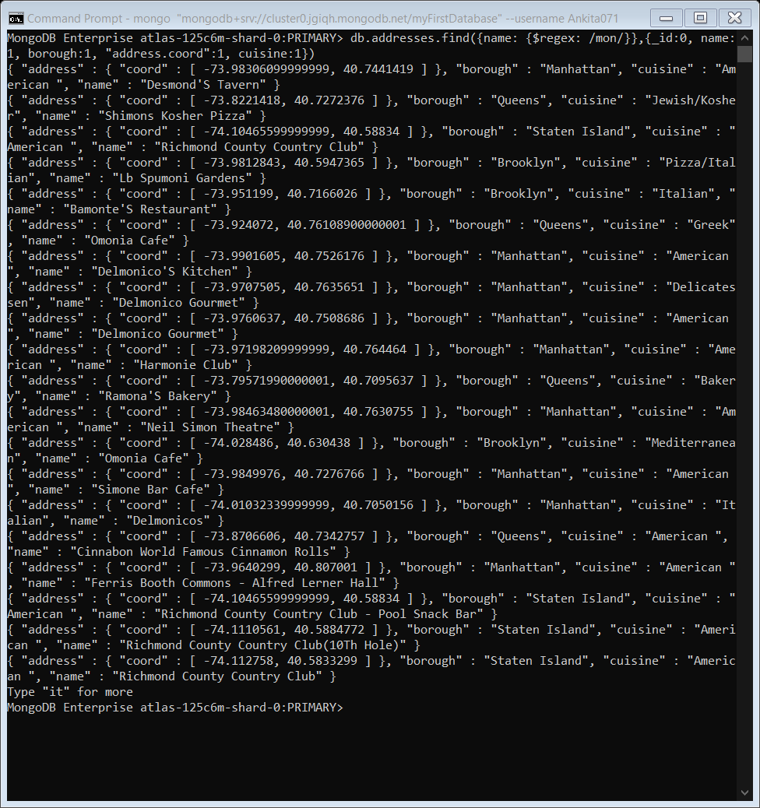

32. Write a MongoDB query to find the restaurant name, borough, longitude and latitude and cuisine for those restaurants which contain 'Mad' as first three letters of its name.

db.addresses.find({name: {$regex: /^Mad.*/}},{_id:0, name:1, borough:1, "address.coord":1, cuisine:1})

